Assignment 1 Worksheet

Aim
To implement a modified Binary Search algorithm to search for a target element in a rotated sorted array that may contain duplicate values.

Objectives
- To understand the concept of a rotated sorted array.
- To implement Binary Search.
- To handle duplicate elements in the array.
- To identify the sorted half of the array.
- To efficiently search for a target element.
- To analyze the time and space complexity of the algorithm.

Question 1: Understand the Problem
Given a rotated sorted array containing duplicate values, determine whether a given target value exists in the array.

Example
nums = [2, 5, 6, 0, 0, 1, 2]
target = 0
The target 0 is present in the array.

Expected Output
True

Question 2: Write the Python Program
Create a file named:
assignment1.py
Write the following program:
def search(nums, target):
left = 0
right = len(nums) - 1

while left <= right:
mid = (left + right) // 2

if nums[mid] == target:
return True

# Handle duplicates
if nums[left] == nums[mid] == nums[right]:
left += 1
right -= 1

# Left half is sorted
elif nums[left] <= nums[mid]:
if nums[left] <= target < nums[mid]:
right = mid - 1
else:
left = mid + 1

# Right half is sorted
else:
if nums[mid] < target <= nums[right]:
left = mid + 1
else:
right = mid - 1

return False

# Input
nums = [2, 5, 6, 0, 0, 1, 2]
target = 0

# Output
print(search(nums, target))

Expected Output
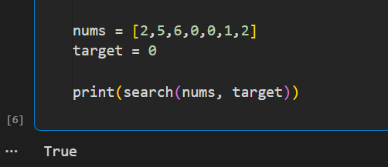

Learning Outcomes
After completing this assignment, students will be able to:
- Understand Binary Search and its limitations.
- Search efficiently in a rotated sorted array.
- Handle duplicate elements during searching.
- Identify the sorted portion of a rotated array.
- Implement a modified Binary Search algorithm in Python.
- Analyze time and space complexity.
- Test the algorithm using different input cases.

